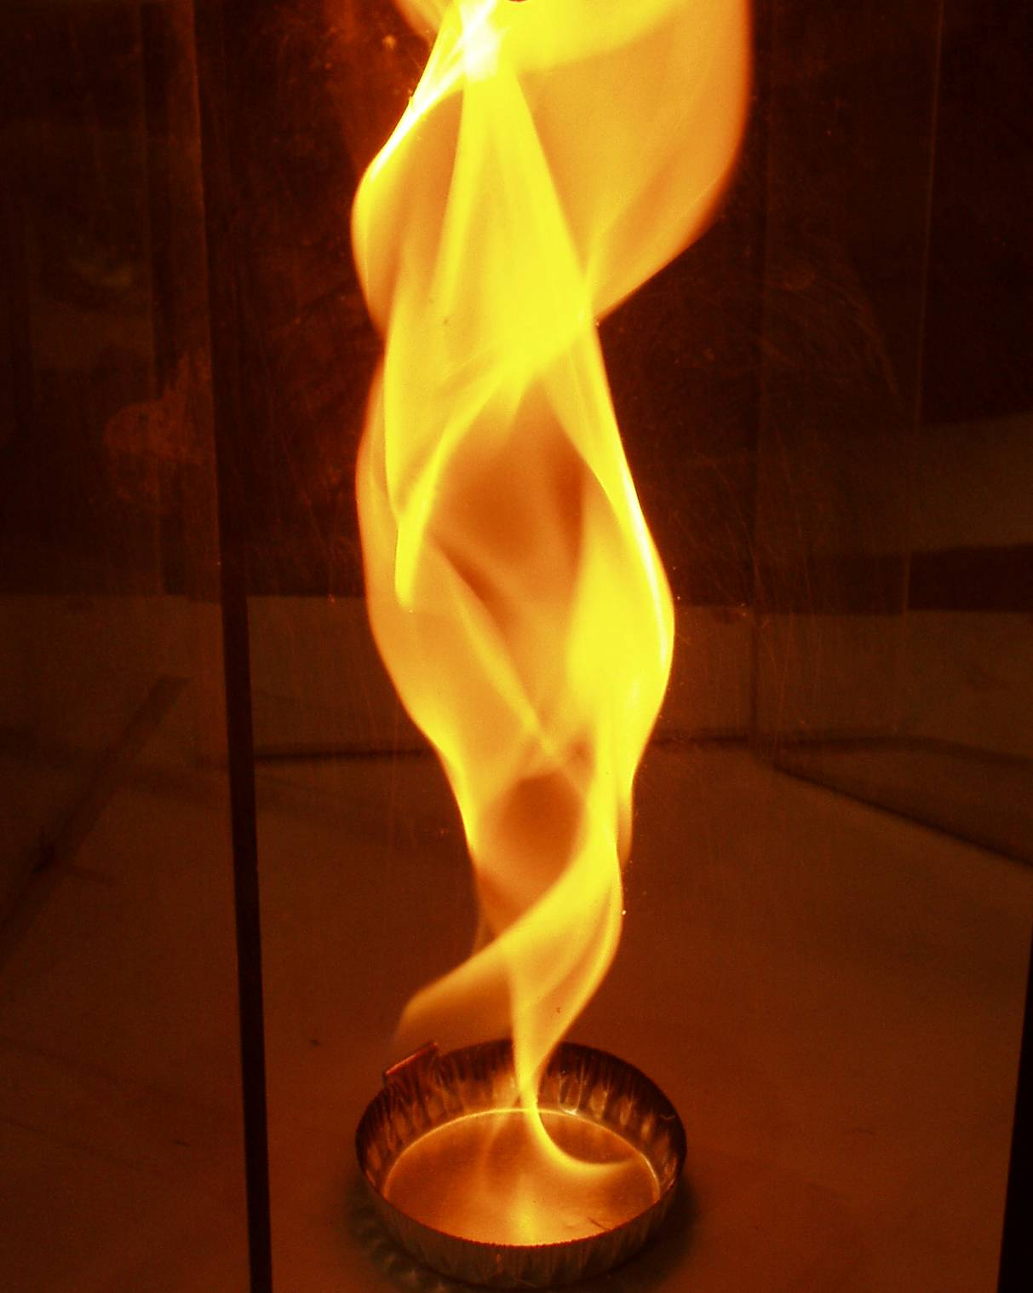
Larry Baxter
July 24, 2007
Entrained-flow Gasifier Model Design
This document outlines the design of an entrained-flow gasifier model (EFGM). This EFGM provides rapid (< 60 s) estimates of gasifier performance suitable for monitoring and eventually control of pilot and commercial entrained-flow coal gasification systems. It also provides reasonably detailed estimates of gas phase, particle, and wall properties, including wall deposition, slag formation, chemical dissolution (corrosion), mechanical fracture, spalling, and erosion.
Idaho National Laboratory,
Brigham Young University

Contents
Contents ii
Figures iii
Abstract 3
Model Data Flow 5
Overall Model Dataflow 5
Input and Reactor Model Data Flow 6
Wall Model Data Flow 8
Fracture model data flow 9
Overall Model Structure 10
Sequence Design 11
Wall Model 11

Figures
Figure 1 Schematic diagram of the gasifier model domain. 4
Figure 2 Highest level data flow diagram. 6
Figure 3 Overall data flow diagram for the model. 7
Figure 4 Data flow among the particle, wall, and gas models. 8
Figure 5 Dataflow within the wall model. 9
Figure 6 Fracture and spalling model data flow details. 10
Figure 7 Structure diagram of EFGM 11
Figure 8 Wall model sequence diagram 14

Entrained-flow Gasifier Model Design

Abstract
This document outlines the design of the entrained-flow gasifier model (EFGM). EFGM provides rapid (< 60 s) estimates of gasifier performance suitable for monitoring and eventually control of pilot and commercial entrained-flow coal gasification systems. It also provides reasonably detailed estimates of gas phase, particle, and wall properties, including wall deposition, slag formation, chemical dissolution (corrosion) and mechanical fracture and spalling, and erosion.
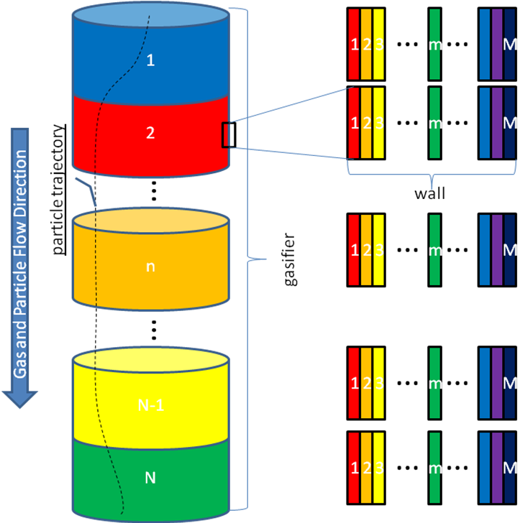
Figure 1 Schematic diagram of the gasifier model domain.
Figure 1 illustrates the geometry and computational domain of the model which is described as follows. The model describes the gas-phase compositions, temperatures, and velocity in an Eulerian framework with one independent spatial dimension (assumes rapid and perfect mixing in the other two dimensions) and as a function of time, where the dimension is along the dominant flow path. Figure 1 illustrates the first and last two of N nodes in this flow direction and an arbitrary intermediate node labeled n, all indicated as cylinders along the generally down-fired flow direction. The colors correspond approximately to the temperatures in a typical gasifier, beginning with cool inlets, producing high gas temperatures as the volatiles combine with oxygen, and decreasing temperature as the endothermic gasification reactions proceed and as heat is lost from the vessel. The flow field is more accurately described as axisymmetric and radially invariant (no gradients in either the tangential or radial directions) than one dimensional. That is, velocities are defined in all three dimensions, but there are no gradients in velocity in the tangential or radial directions. Thus, flows expand from a central inlet and contract to a central exit and may swirl, but the only dimension that shows variation in the expanding, contracting, or swirling flow is the axial dimension.
The model also describes the particle temperatures, compositions, and trajectories within gas flow field. The particle trajectories are three dimensional and depend on residence time and Eulerian time. Figure 1 illustrates a single particle trajectory. Typically there would be multiple trajectories representing different particle sizes, starting locations, or types.
Finally, the model includes a two dimensional, time dependent Eulerian wall model, with one dimension associated with the gas-phase nodes and a second dimension orthogonal to the gas flow direction. Figure 1 illustrates the first and last three and an arbitrary intermediate node of M wall nodes at each of the N gas nodes. The color again represents typical temperature variation within the wall, with the inside being the hottest and a monotonic but non-linear temperature decrease with increasing radial distance. The inside boundary of this node is the edge of the deposit or slag layer generated by the particles and the outside extends through the deposit/slag layer, the ceramic liner, to the outer edge of the metallic containment vessel where a boundary condition can be identified. The wall model includes deposit accumulation and chemical and physical interactions with the gasifier liner, including its dissolution and spalling. As indicated, the physical dimensions of the each slag layer are very small compared to those of the overall reactor.

Model Data Flow
The next series of diagrams show how data passes from one block to another in this computer code. Square-cornered boxes represent some sort of interface with a person, external code, database, or similar resource. Round-cornered boxes represent program processing elements (subprograms, etc.).

Overall Model Dataflow
Figure 2 illustrates the dataflow in this model at its highest level. A system monitoring and control module issues a required for reactor conditions. The reactor model generates estimates of measurable system outputs (vessel wall temperature profile, exit gas composition and temperature, slag flow rate, and possibly a few other properties). The model also generates detailed and probably not measureable reactor characteristics, such as slag and refractory thickness, gas velocity, temperature, and composition profiles, wall temperature, composition, dissolution, and fracture profiles, surface deposition, slagging, and emissivity profiles, etc. The control program primarily deals with liner wear and external wall temperature profiles, both of which are returned from the model. These non-measurable characteristics include information critical to reactor operation, such as liner thickness and dissolution rate. This estimated information does not support reactor control (since the corresponding process characteristics are non-measureable) but remains useful for monitoring and diagnostic purposes. The model records a complete set of estimated reactor characteristics a data repository (file or data structure) for these reasons.
Figure 2 Highest level data flow diagram.
This discussion now shifts to a more detailed discussion of the inputs and the reactor model.

Input and Reactor Model Data Flow
Figure 3 illustrates the overall dataflow diagram in more detail than Figure 2. In particular, at least three types of input define the reactor operation: time of operation (part of the module request), reactor design (size, materials, etc.), and reactor operating conditions (gas and particle flow rates and properties such as coal type, oxygen purity, etc.). These inputs appear at the top of Figure 3 in the Input box. Additional required input information not shown here to decrease clutter is a large amount of database information describing materials properties and their pressure and temperature dependence.
The reactor model includes gas, particle, and wall submodels as its three primary submodels. These are interdependent and must be solved by iteration, as will be discussed later, but at this level the general flow of information is indicated. The gas model estimates particle mass source terms and wall conditions and calculates the gas field properties such as velocity, temperature, composition, and turbulence parameters. The particle submodel estimates particle mass loss, heat transfer, temperature, trajectories, and related information using the results from the gas model. New and more accurate gas source terms and Eulerian representations of the Lagrangian particle properties are among the particle model estimated results. The particle model also provides information required to estimate local deposition rates on the reactor wall. The wall model estimates temperature, composition, dissolution rate, and fracture characteristics as a function of radial position in the wall at each axial location, using results from both the gas and particle models. The wall model also estimates surface slag flowrate and emissivity.
Iterations through these three models continue until they converge. The iteration process is implied but not included explicitly in this dataflow diagram. Figure 4 illustrates many of the same ideas discussed above with an emphasis on the information exchange among the three major components of the reactor model.
Figure 3 Overall data flow diagram for the model.
The entire model is designed to be repeated at time intervals specified by the user/monitoring and control module. These transient time steps consist of exercising all components of the model thus far discussed at each time step. However, only the wall model includes transient terms. The gas and particle models assume a pseudo-steady operation, meaning that transport equations involve average values of velocity, temperature, and composition, with instantaneous values represented only in the mean as root-mean-square turbulent fluctuations. These steady-state properties doe depend on the (transient) wall conditions of, for example, emissivity, temperature, and to a much lesser extent slag flow rate. The wall deposit thickness is nearly always trivial compared to the overall reactor dimensions, so the average gas velocities exhibit negligible dependence on the deposit thickness.
The weak dependence of the gas and particle models on the transient wall conditions provides an opportunity to significantly simplify the model in practice. The simplified version of the model we call the light or thin version and it assumes that he gas and particle conditions are independent of the wall conditions. The thin/light mode reuses the gas and particle models from a converged set of gas, particle, and wall conditions and only recomputes the wall conditions at successive time steps. The heavy/thick/complete version recomputes the gas, particle, and wall model results at each time step.
The next section of this document focuses on data flow in the wall model.
Figure 4 Data flow among the particle, wall, and gas models.

Wall Model Data Flow
The wall model has several major subcomponents: the heat transfer, composition, mechanical wear submodels, the last of which is discussed in more detail later. The heat transfer component estimates the temperature profiles, heat fluxes, and related characteristics of the wall. All other submodels depend strongly on the temperature profiles, so it is the first estimate provided. On the first iteration, it uses ad hoc estimates of the composition and fracture/spalling characteristics of the wall. The solution requires iteration of all four, interdependent components.
The second subcomponent estimates the solid and liquid compositions of the slag, liner and metal container that together constitute the wall. These composition and phase estimates depend very strongly on temperature and the numerical methods used to provide these estimates are closely coupled. In this sense, the separation of heat transfer and composition into different components is more conceptual than actual. Finally, the temperature and composition profiles provide data to the mechanical modules. The mechanical modules estimate the physical decomposition of the ceramic liner based on the temperature and composition gradient estimates. It returns estimates of fracture dimensions (length, width, tortuosity) and concentration, spalling, and erosion. The composition model uses these estimates to determine liquid penetration in fractures and inherent pores of the ceramic liner.
Figure 5 Dataflow within the wall model.
The coupling among the submodels requires an iterative solution procedure. After the iterations converge, the resulting wall temperature, composition, dissolution, fracture, and related results provide the pass back to the overall model computation control and eventually appear in part in the measurable process characteristics output (wall temperature, exit slag composition, etc.) and in total in the detailed model output archive.

Mechanical model data flow
Wall Model Data Flow illustrates the wall mechanical model data flow, where fracturing, spalling, and erosion are modeled. Fracturing greatly enhances liquid penetration and substantially weakens the liner, both leading to more rapid liner degradation. The size, depth, orientation, and concentration of the fractures all contribute to this wear. These are predicted in the fracture module.
Spalling, in this context, represents a portion of the liner disconnecting from the bulk liner and becoming suspended in slag or falling from the surface. The spalling model determines the depth of the spall (new liner thickness) and size distribution of the spalled material.
Erosion is the mechanical wear of the surface by abrasive fly ash impaction. This is only an issue when the liner surface is exposed because of low deposition or very low slag viscosity. The erosion module predicts the rate of surface regression by this mechanism.
Figure 6 Fracture, spalling, and erosion data flow details.
These data flow analyses provide a conceptual overview of the model. Detailed model implementation requires a much more formal, detailed, and less approachable design approach. Although it is dominantly graphically oriented, the graphs so not necessarily lent themselves to intuitive interpretation. The remainder of this document provides a graphical outline for the model.

Overall Model Structure
Figure 7 illustrates the overall model structure. All of the components shown at this level are packages, i.e., generic aggregates of model capability without specific attributes or methods. A user interface provides information needed to describe the particle and gas models. This interface may be a GUI interfacing with a person or a set of subprogram calls from a supervisory control or other computer-based algorithm. The combination of the particle and gas models provides estimates of the wall behavior, specifically the slagging and liner degradation rates. These three components (particle, wall, and gas models) constitute the essential model components. They are interdependent and time variant, although early implementations of the model ignore the time variation. The time variation included here represents relatively long (many minutes to a few hours) time steps during which the gas and particle models change little. Only the boundary conditions of the gas and particle models change, and these changes are dominated by temperature. The wall model, however, changes dramatically, with deposit thickness, slag formation, etc. changing at each time step.
One potentially confusing aspect of these diagrams is that the arrows represent dependencies, not data flow. For example, Figure 7 shows that the particle, wall, and gas model all depend on thermochemical equilibrium and kinetic calculations. However, the kinetic and thermochemical calculations are conceptually independent of any given set of particle, wall, or gas conditions. That is, they depend on the elemental composition and temperature of a given phase, but they do not depend on temperature or composition profiles, gas velocity, or other essential outputs from the particle, wall and gas models. Also, the numerical methods and chemical/physical databases contribute in many places (all of the places shown in Figure 7) to the code, but dependency arrows are not included to avoid clutter.
Figure 7 Structure diagram of EFGM
The results of the model include spatially (one dimension along the flow path) dependent gas composition, temperature, and velocity estimates with corresponding residence-time-dependent particle composition, position, velocity, and temperature estimates and, at each flow node, one-dimensional (orthogonal to the flow direction) wall composition, phase, thickness, heat flux, flow velocity (for slag), thermal conductivity, strength, porosity, and temperature estimates. The wall model also includes emissivity estimates at the innermost node, Node 1. The remainder of this document discusses each of the major model subcomponents.

Sequence Design
Sequence diagrams indicate the order in which a model executes various tasks. Such diagrams are read from the upper left corner. The diagram shows sequential processes (or, if several appear at the same horizontal location, parallel processes) in order from top to bottom. It shows various tasks in order from left to right. The task titles are not necessarily the same as object or class titles in the code but are descriptive titles related to the tasks being performed. Beneath each task title is a vertical dashed line that represents the lifetime (time of existence) of each task. Sections of the vertical line represented by slender rectangles indicated regions where the task is active. Regions without these slender rectangles indicated that capability still exists in the code (the class has not been destroyed) but is not actively working. Importantly, the horizontal lines representing interactions between modules connect only the modules with direct interactions. A message or method call (horizontal line) that crosses but does not terminate at a lifeline of a module (vertical lines) does not imply that the crossed-over module is involved in the communication.

Wall Model
Figure 8 illustrates the wall model sequence diagram. The wall property domain existing in an Eulerian framework. The Computational Control module establishes a grid and initial estimates, if needed, for the wall properties, as shown by the calls to the Wall grid and early calls in the Compute Properties modules.
After these preparatory stages, the wall model computes the temperature, composition, and fracture profiles through the wall and determines the extent to which the wall spalls (essentially instantaneous loss of connectivity of a wall section) and erodes. If the wall spalls or erodes, the Spall module calculates the size distribution of the spalled material. The interdependence of these computations requires iteration to find a consistent converged solution. Upon convergence, the model stores details in a data structure and increments time.
The wall model is inherently transient, so this sequence repeats at each time step. These time steps represent elapsed time and typically are on the order of hours, unlike the particle model time steps that represent residence time and are small fractions of a second. One way to distinguish between these different concepts of time is to consider steady-state operation. At steady state, the particle model time steps remain small fractions of a second whereas the wall model time steps effectively become infinite. If changes in the gas and particle phases are insignificant, only the wall model needs to be rerun at each successive wall model time step. More rigorous and time-consuming calculations that recalculate the gas and particle phases at each time step rerun the entire reactor model (gas, particle, and wall) at each step. The only substantial changes for the gas and particle models between wall time steps are the axial wall temperature profile and surface conditions. These changes from the initially converged solution commonly have relatively little effect on the particle or gas models and can be neglected if computational time is a premium.

Figure 8 Wall model sequence diagram

